Study of IP Addressing and sub-netting.

**Practical Assignment #09:**

1. Find default subnet marks, network bits, host bits, hosts per subnet, no of subnets, subnet number, 1st valid IP address, last valid IP address, and broadcast address.
   1. 8.1.4.5/16
   2. 130.4.102.1/24
   3. 199.1.1.1/24
   4. 130.4.102.1/22
   5. 199.1.1.100/27

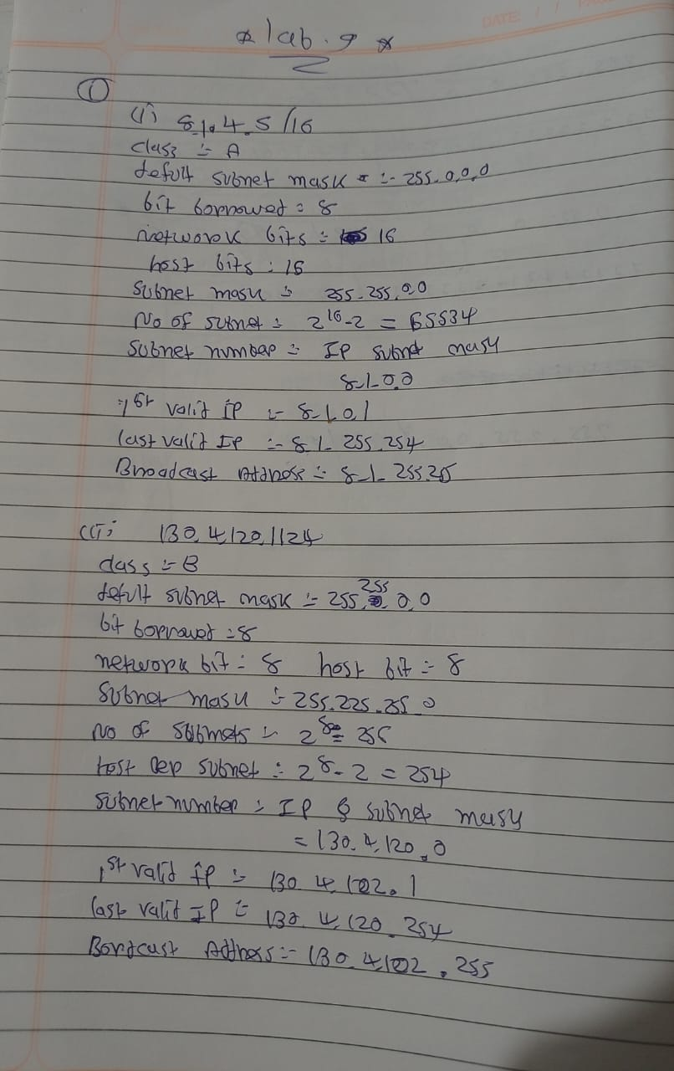

1. A host in a class C network has been assigned an IP address 192.168.17.9. Find the number of addresses in the block, the first address, and the last address.

1. An address in a block is given as 185.28.17.9. Find the number of addresses in the block, the first address, and the last address.

1. A block of addresses is granted to a small organization. We know that one of the addresses is 205.16.37.39/28. What is the first address, last address, number of addresses in a block.

1. Subnet the IP address 216.21.5.0 into 30 hosts in each subnet. Find Class, Default Mask, Bit Borrowed, New subnet mask, No. of Hosts & Subnet, Network Ranges (Subnets).

1. Subnet the IP address 192.10.20.0 into 52 hosts in each subnet. Find Class, Default Mask, Bit Borrowed, New subnet mask, No. of Hosts & Subnet, Network Ranges (Subnets).

